**TRICHY ENGINEERING COLLEGE**

**SIVAGNANAM NAGAR, KONALAI , TRICHY-621105.**

**CENTRAL BANK SMART CONTRACT PROJECT**

**ON**

**BLOCKCHAIN TECHNOLOGY**

**PROJECT HEAD – M. RAJATH (814620114005 )**

**PROJECT MEMBERS:**

**M.RIYAS AHAMED (814620115303)**

**T. MANOJ KUMAR (814620115002)**

**R. DINESH KUMAR (814620114304)**

1. **INTRODUCTION**

**1.1 Project overview:**

With the development of [blockchain](https://www.sciencedirect.com/topics/computer-science/blockchain" \o "Learn more about blockchain from ScienceDirect's AI-generated Topic Pages) and digital currencies, **central banks** all over the world are accelerating the process of CBDC development. However, it is still controversial on adoption of blockchain in CBDC design. In the paper, we analyze both functional and non-functional requirements of CBDC design, and make a literature review on blockchain based CBDC schemes. Analysis findings show that permissioned blockchain is more suitable for CBDC than permissionless blockchain. Besides, there are some challenges in blockchain based CBDC, such as performance, scalability, and cross-chain interoperability. Our analysis is timely and can provide guidelines for blockchain based CBDC design.

**1.2 Purpose:**

The blockchain also uses cryptography to ensure that only authorised parties can access and validate **transactions.**

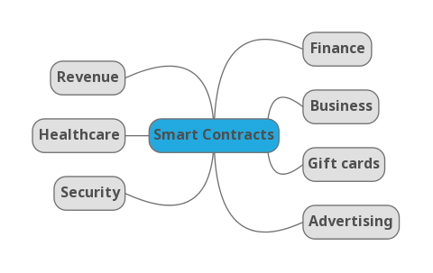 This technology has the potential to revolutionise the way banks operate, enhancing security, increasing efficiency, and potentially reducing costs. In this article, we will explore the benefits of blockchain technology in banking and some of its potential use cases.

1. **LITERATURE SURVEY**

**2.1 Existing Problem:**

Let’s dig deeper into the crypto world. There are new phenomena—Ethereum(ETH) and smart contracts—based on cryptocurrency, thanks to Vitalik Buterin, one of the most famous developers of blockchain technology in the modern world. In this article, you will familiarize yourself with the main functions, possible uses of smart contracts, and benefits, in addition to the spheres where can we use them.

**2.2 References :**

**1. Nakamoto S**.

Bitcoin: A peer-to-peer electronic cash system

(2008).

**2. Dashkevich N., Counsell S., Destefanis G.**

Blockchain application for central banks: A systematic mapping study.

**3. Esposito Christian, Ficco Massimo, Gupta Brij Bhooshan**

Blockchain - based authentication and authorization for smart city applications.

**2.3 Problem Statement Definition :**

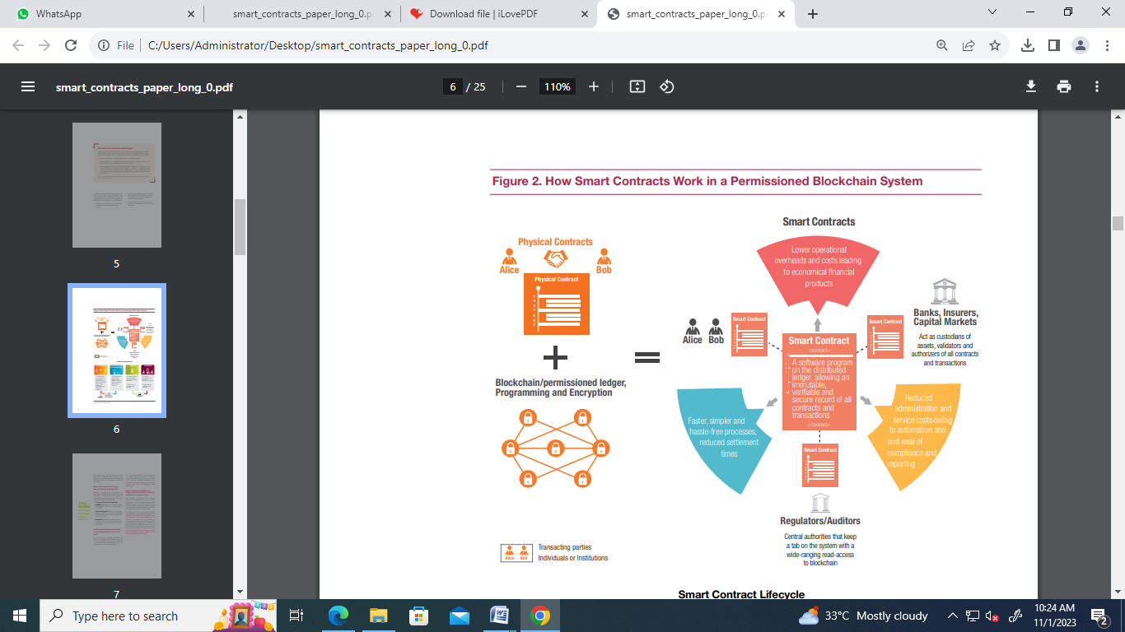

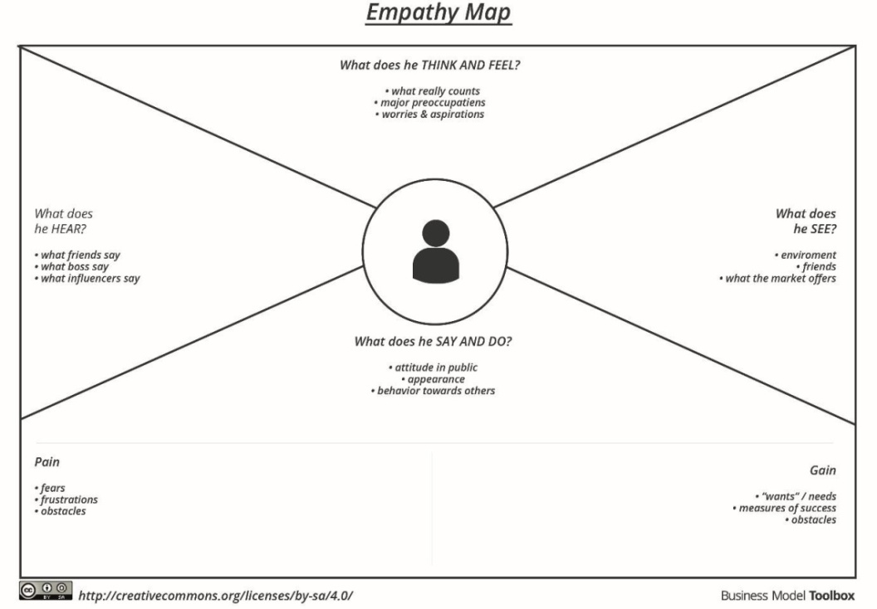**3. IDEATION & PROPOSED SOLUTION**

**3.1 Empathy Map Canvas :**

How to budget upcoming wedding expenses?

Will I achieve my life goals?

How will be my appraisal?

Many millennials are commuting

long distances to find homes

Bigger banks are providing

Online support

Stock market is now a big bubble.

Watching lower Interest rates ad

Colleagues buying houses

Friends going on vacation

Overdraft alert notification

Check account balance

Deposit check in bank

Create FD and RD

Setup bill payments

**PAIN**

No visibility on spending pattern

Getting late alerts on overdraft

**GAIN**

Need saving goals

To manage money

**4 . SYSTEM ARCHITECTURE :**

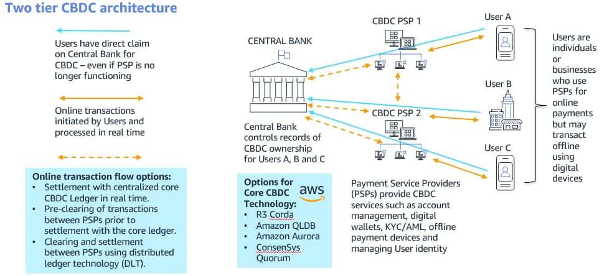

1. **PROJECT DESIGN**

**5.1 Data flow Diagram:**

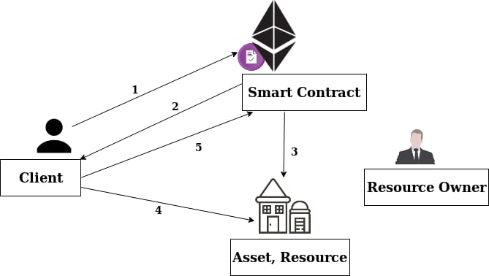

**5.2 Solution Architecture:**

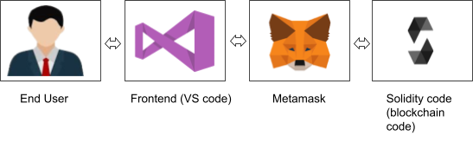

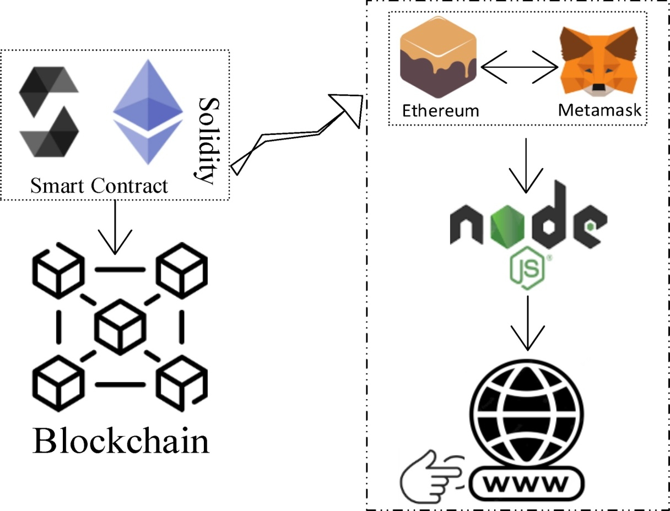

**PREREQUISITES :**

1. download node.js : [Node.js](https://nodejs.org/en)
2. download vs code
3. download metamask : <https://metamask.io/>

# STEPS TO COMPLETE :

# Step 1:-

1. Open the Zip file and download the zip file. Extract all zip files

# Step 2 :

1. Open vs code in the left top select open folder. Select extracted file and open .
2. Select the projectname.sol file and copy the code.3.
3. Open the remix ide platform and create a new file by giving the name of projectname.sol and paste the code which you copied from vs code.
4. Click on solidity compiler and click compile the projectname.sol
5. Deploy the smart contract by clicking on the deploy and run transaction.
6. select injected provider - MetaMask. In environment.
7. Click on deploy. Automatically MetaMask will open and give confirmation. You will get a pop up click on ok.
8. In the Deployed contract you can see one address copy the address.9.
9. Open vs code and search for the connector.js. In contract.js you can paste the address at the bottom of the code. In export const address.10.
10. Save the code.

# Step 3:

open file explorer

1. Open the extracted file and click on the folder.
2. Open src, and search for utiles.3.
3. You can see the frontend files. Select all the things at the top in the search bar by clicking alt+ A. Search for cmd
4. Open cmd enter:

npm install

npm bootstrap

npm start

1. It will install all the packages and after completing it will open {LOCAL HOST IP ADDRESS}

copy the address and open it to chrome so you can see the frontend of your project.

**6. RESULTS :**

**1).Installing VS Code:**

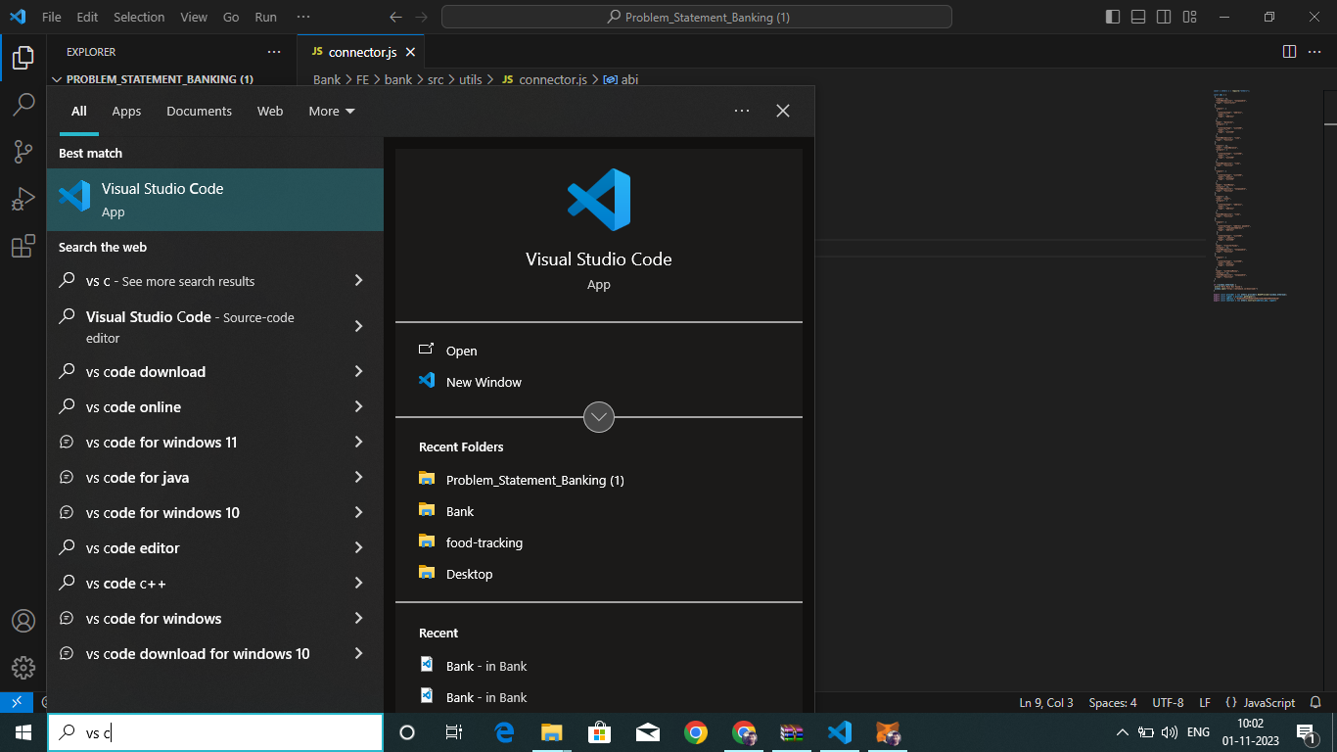

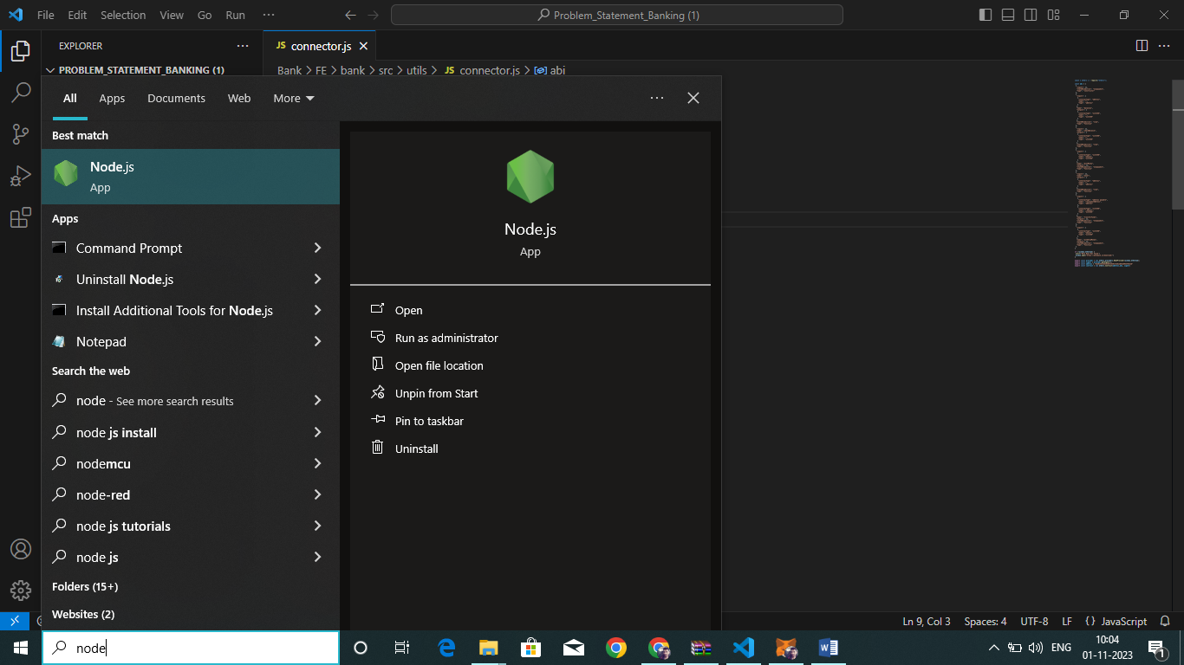**2). Installing Node- JS:**

**3). Connect to Meta Mask & Deploy the Program:**

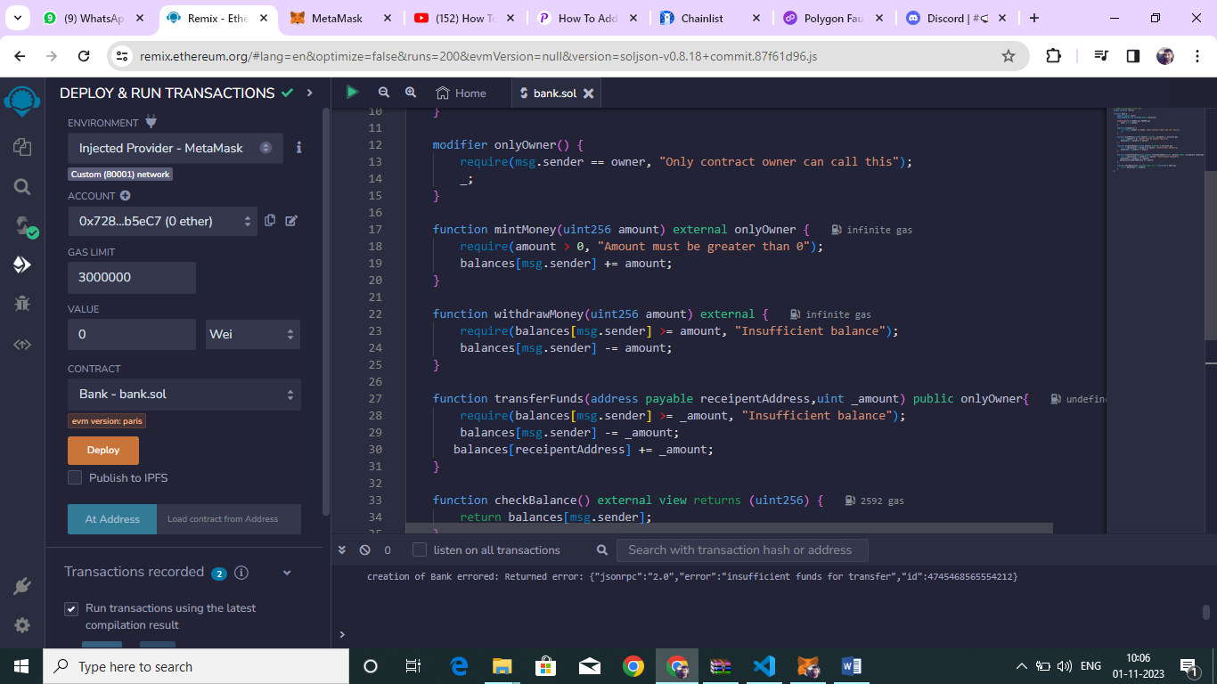

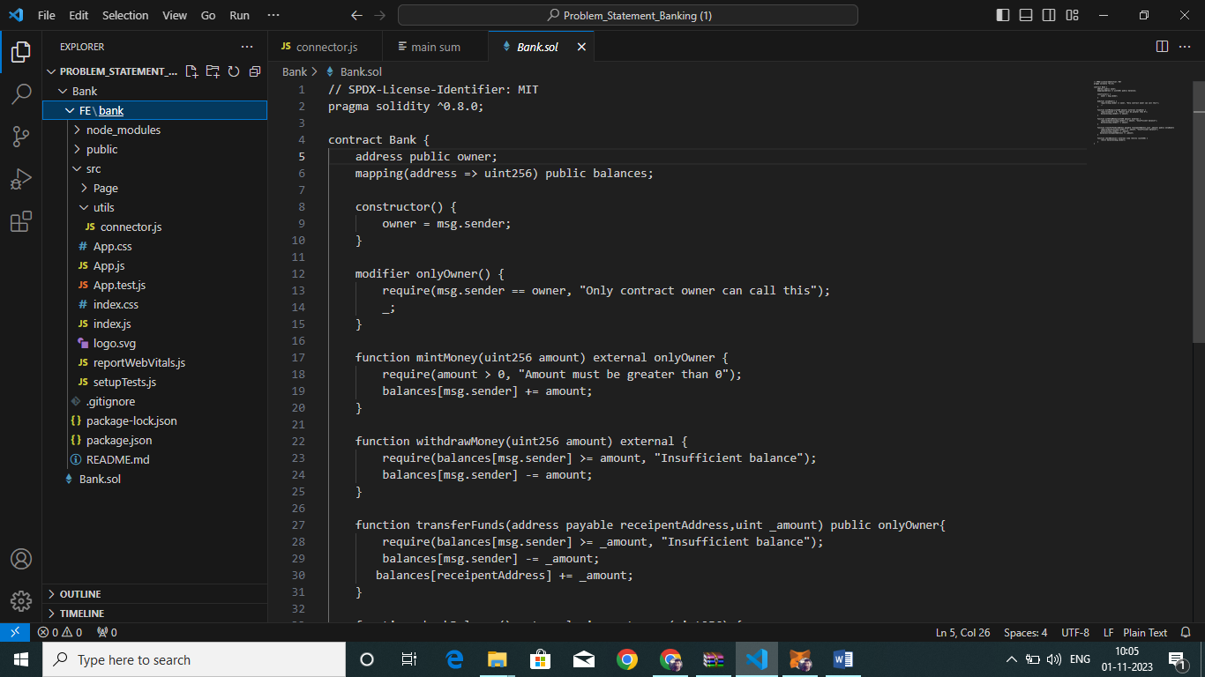**4). Open folder and select Connector.js :**

**5). Open cmd and generate local IP address:**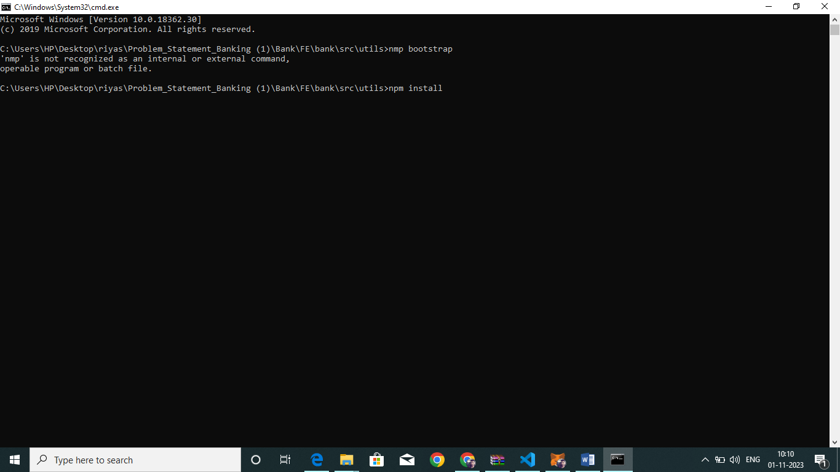

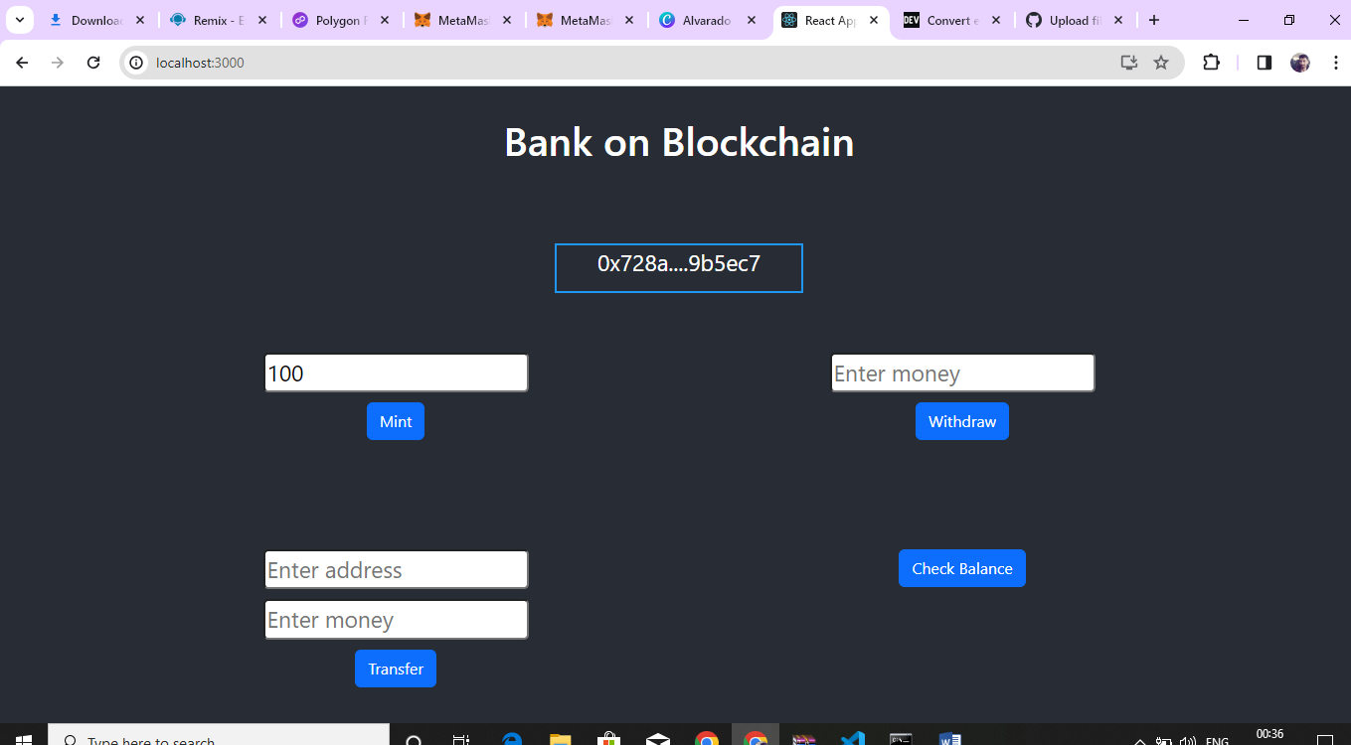**6 ). Output of Frontend :**

**7. ADVANTAGES & DISADVANTAGES :**

**Advantages :**

* Increased efficiency of transactions: CBDCs could potentially streamline payment systems and reduce settlement times, enabling faster and more convenient transactions.
* Enhanced financial inclusion: CBDCs could provide greater access to financial services for individuals and businesses who are currently underserved by traditional banks.
* CBDCs could potentially lower the cost of printing and circulating physical cash, as well as reduce the need for intermediaries in payment systems.

**Dis - Advantages :**

* Risk of bank runs and system instability: If there is a sudden surge in demand for CBDCs, it could cause a bank run and potentially destabilize the financial system.
* Depending on the design of the CBDC system, there is a risk that central banks could use their power to manipulate the economy or make decisions that are not in the best interest of society.
* Difficulty in implementing anti-money laundering and counter-terrorism financing measures: CBDCs could be more difficult to monitor and regulate than physical cash, which could create challenges in preventing money laundering and terrorism financing.

**8. FUTURE SCOPES :**

